Elder Street Car Park – Application Pack

|  |  |
| --- | --- |
| NAME |  |
| ADDRESS |  |
| PHONE |  |
| EMAIL |  |
| CAR REGISTRATION |  |
| RELATIONSHIP TO Ainslie+Gorman | *Please tick all that apply:*  Ainslie+Gorman Staff Member  Individual Resident  Staff of Resident Organisation  Regular Venue Hirer  Regular Attendee of Ainslie+Gorman  Parent / Guardian/ Caretaker of regular attendee of the A+G  Staff member of Ainslie Primary School  Parent/Guardian/Caretaker of Ainslie Primary School student  No existing relationship to Ainslie+Gorman  Other (Please Specify): |

Terms + Conditions

1. CHANGE OF INFORMATION

You agree to notify Ainslie+Gorman, in writing, of any changes to the information provided in this form within ten (10) business days of the change. This includes changes to contact details or changes to your relationship with Ainslie+Gorman.

1. CONTRACT + FEES

Month-to-month basis, $243.75 (inc. GST) per calendar month including direct debit fees, payable in advance. Late payment fee is $9.90.

* Contracts are established on a month-to-month basis with a minimum initial commitment of two months required.
* The parking fee is $243.75 (inc. GST) per calendar month, contingent upon agreement to our terms and conditions. Fees are pro-rated if the contract begins mid-month. Access is granted only after all necessary information and documentation are completed.
* Fees are charged monthly via direct debit, payable in advance, and must be settled on or before the first working day of each month for the subsequent month. There are no discounts for public holidays or absences.
* Direct debit payments are processed using EziDebit. Payments are automatically drawn from your bank account or Visa/Mastercard/Amex on the first day of each month. All EziDebit transaction fees are included in the monthly fee, except for late payment charges, which incur an additional fee of $9.90 (inc. GST).
* Parking rights to the Elder Street Car Park will be suspended if payments are not received within the first seven (7) days of the month. Patrons must keep their accounts current to maintain parking rights.

1. ACCESS + BAY ALLOCATION

Designated parking bays, secure access from 7:00 am to 5:00 pm on business days. The car park is situated behind Ainslie Arts Centre on Elouera Street, Braddon, with access via Elder Street. Here is a [**Google Maps link**](https://maps.app.goo.gl/emTp4PQZjMnMkPAj9) to the location.

All parking spaces are designated; you are required to park only in the bay(s) allocated to you. Please be aware that this is an open-air car park, and vehicles may be exposed to weather conditions and foliage debris.

Secure boom gate access is operational from 7:00 am to 5:00 pm, Monday through Friday (Business Days). Outside these hours, and on weekends, the boom gate remains open, and the car park is accessible to the public.

The boom gate is controlled remotely. A refundable deposit of $100 (inc. GST) is required prior to the start of your agreement. This deposit will be returned upon the conclusion of your hire, provided the remote is not lost or damaged.

1. TERMINATION

Patrons must provide five (5) business days’ notice prior to the end of a month if they wish to terminate their parking agreement for the following month. Should notice be given after this deadline, parking fees for the subsequent month will be incurred.

Ainslie+Gorman reserves the right to terminate agreements at any time, with written notice, under the following circumstances:

* breach of any terms and conditions by the patron; and/or
* necessity to close the facilities due to Federal and/or Territory Government directives, or any other legal requirements that mandate such action.

1. INDEMNITY

Arts Capital is not liable for any injuries or damages incurred within the Elder Street Car Park; patrons are required to indemnify Arts Capital Limited against all losses.

By entering and using the car park, you do so at your own risk. Arts Capital is not liable for:

* injury to you or any accompanying person;
* damage to, destruction of, or theft of your vehicle; and
* damage to, destruction of, or theft of any property within or on your vehicle, regardless of how it occurs.

You agree to indemnify Arts Capital for any costs, expenses, losses or damages incurred by us in connection with any death, personal injury, or damage to real or personal property caused directly or indirectly by your vehicle in the car park.

1. VARIATION OF TERMS + CONDITIONS

We reserve the right to amend the terms and conditions of this agreement at any time. Should there be any changes, you will receive a written copy of these alterations at least ten (10) business days prior to their implementation.

Acceptance

I hereby agree and accept the Terms + Conditions for the Ainslie Arts Centre Elder Street Car Park and acknowledge that the information I have provided on this form is accurate and truthful.

Full Name:

Signature: Date:

Please direct all car park enquiries to the Ainslie+Gorman Main Office via 02 6182 0000 or [enquiry@ainslieandgorman.com.au](mailto:enquiry@ainslieandgorman.com.au)

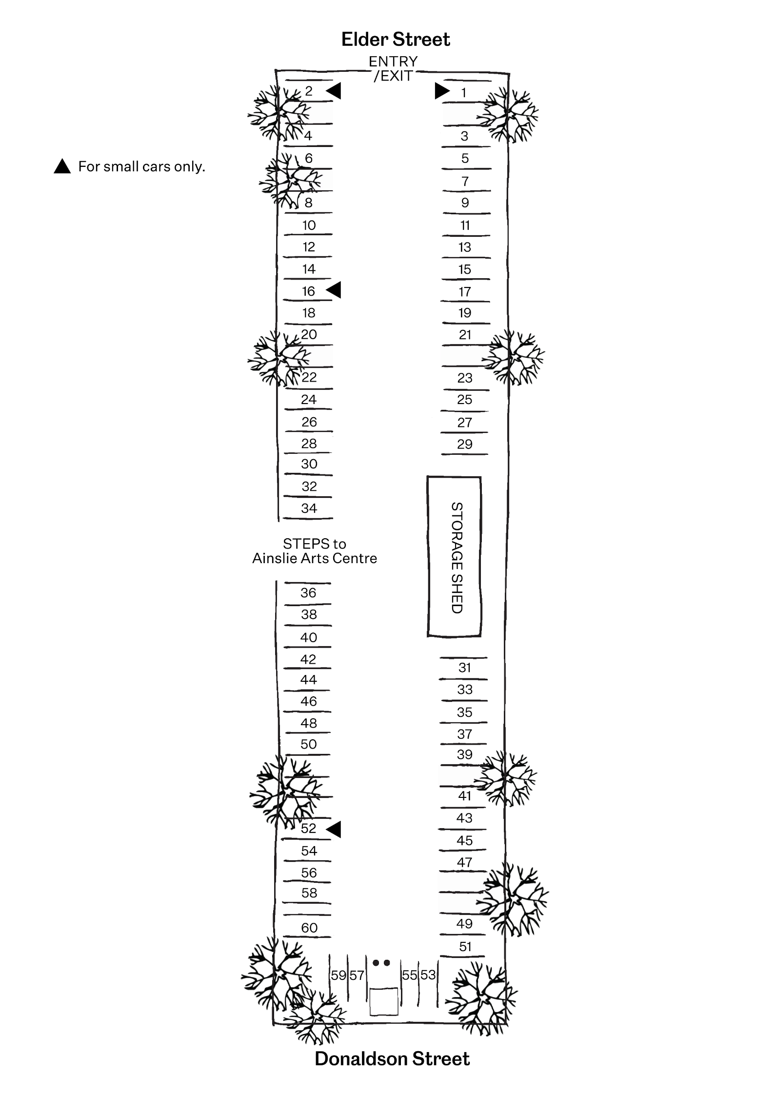Elder Street

Car Park Map